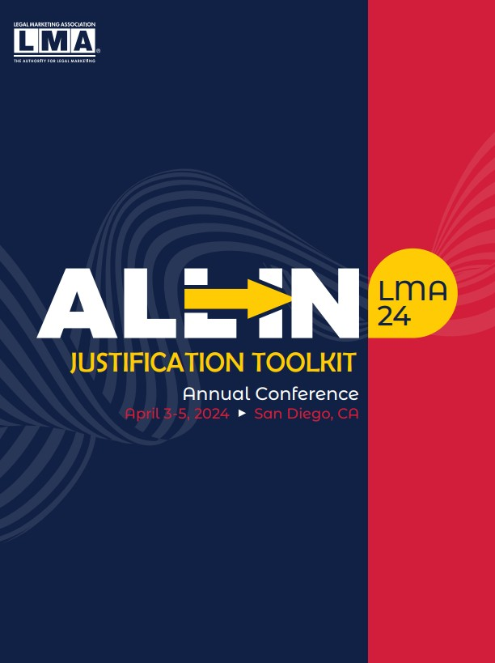

San Diego Marriott Marquis Marina, San Diego, CA
April 3-5, 2024

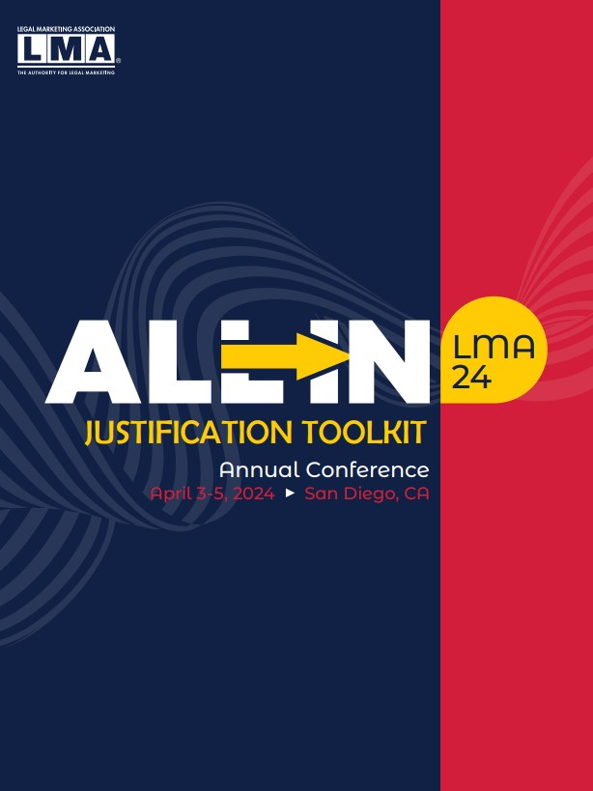STEP 1: Identify Your Firm's Motivation
When Deciding Your Attendance

To effectively justify your attendance, you will need to articulate the connection between your firm's knowledge and skill requirements and how attending the conference can help you meet those needs. Below are some questions your manager may have and suggested answers you could give.

What is the LMA Annual Conference?

The LMA Annual Conference is the largest global continuing education event for legal marketing and business development professionals. From April 3-5, 2024, more than 1,000 legal marketers from firms of all sizes, along with preeminent industry partners, will attend to learn about and discuss changes within the industry, identify solutions to current challenges and uncover opportunities to meet their firms' goals.

What is the benefit of the networking?

I will meet legal marketers and business development professionals at all levels in their careers, from CMOs to specialists. There will be legal marketers from law firms of various sizes and from across North America, Europe and beyond. That is a large pool of experiences, ideas and solutions I will be able to tap into — both during and after the event. In addition to law firm colleagues, there will be a wide variety of solution providers in attendance, giving me the opportunity to evaluate new products and services that may benefit our firm and stay out in front.

How will your firm benefit from your attendance?

Through interactive workshops and discussions, I will learn about strategies employed to generate new business and achieve a competitive edge in today's legal landscape. The conference program also gives me access to the ‘voice of the client’ to better understand the shifting priorities of firm clients — as well as how to utilize technology in a meaningful way. I'll return with actionable ideas and new perspectives that will help our firm navigate today's evolving business environment.

How will your firm’s reputation benefit?

Beyond bringing vital information back to the firm, I will also be a representative for the firm and ensure that we are increasing brand awareness amongst our industry peers and leading industry partners.

Use #LMA24 on Social lma24.legalmarketing.org

STEP 2: Identify How Your Attendance Will
Meet Your Firm's Needs

Use the following table to help you determine how your attendance will meet the needs of your firm (see example below).

CURRENT NEEDS
HOW ATTENDING #LMA24 WILL HELP MEET THOSE NEEDS

Improve client experience and retain existing clients Generate new business
Enhance the visibility of your firm and improve the legal marketing team

Gain insights into how other law firms are addressing today's business environment
Attend 1 of our 5 Pre-Conference Programs that are tailored to various LMA audiences, covering topics including innovation, business development and more

Learn innovative approaches and strategies to drive new business to your firm

30+ sessions covering essential to advanced competencies in legal marketing and business development

Hear case studies from clients and in-house legal marketing professionals on how priorities have shifted and what they foresee coming

Now it's your turn! Use the table to enter current needs unique to your firm.

CURRENT NEEDS
HOW ATTENDING #LMA24 WILL HELP MEET THOSE NEEDS

Use #LMA24 on Social lma24.legalmarketing.org

STEP 3: Make the Ask and Receive
Approval to Register
Now that you've identified the benefits to your professional development and your firm, below is a template that you can customize and use in your communication with your
manager.

SUBJECT
Upcoming Professional Development Opportunity at the LMA 2024 Annual Conference

Hi [ Insert Name],

I am interested in attending the LMA 2024 Annual Conference, held April 3 - 5 in San Diego, CA. I have outlined below the direct business benefits to the f irm as well as how attending would positively impact my professional growth. I f you have any questions, please let me know, and I will be able to provide additional information.

The LMA Annual Conference is the largest and most important gathering of legal marketing and business development professionals and an opportunity for me to learn from thought leaders in
this space. The event attracts more than 1,000 legal marketers — from CMOs to specialists — from law firms of all sizes.

This year's event is especially important as our law firm continues to successfully advance and look for new ways of attracting and retaining business. No other conference provides the same high-
caliber, actionable education that legal marketers like me need to succeed.

I 've also outlined some of the business opportunities our firm has and how this conference can
help us find actionable solutions. After the conference, I will provide you and the team with a full conference summary outlining the lessons I learned and my recommendations for how we can implement them.

[ Insert benefits identified in step 2 or specific sessions or topics offered that are most relevant to your firm.]

The specific benefits to our firm resulting from my attendance at this year’s annual conference are substantial, making this an appropriate use of our professional development budget and my time. Group rates are also available and a great opportunity for more of our colleagues to participate in this timely content at a fraction of the cost.

If I register early, I can take advantage of early-registration discounts.

I appreciate your consideration of my request. If you would like to discuss this further, please let me know.

Sincerely,
[ Insert Your Name]

Use #LMA24 on Social lma24.legalmarketing.org

